Hashmap in Selenium

What is Hashmap in Java?

A HashMap basically designates unique keys to corresponding values that can be retrieved at any given point.

Features of Java Hashmap-
a) The values can be stored in a map by forming a key-value pair. The value can be retrieved using the key by passing it to the correct method.
b) If no element exists in the Map, it will throw a ‘NoSuchElementException’.
c) HashMap stores only object references. That is why, it is impossible to use primitive data types like double or int. Use wrapper class (like Integer or Double) instead.

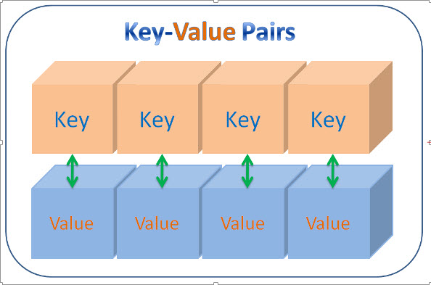

Using HashMaps in Java Programs:
Following are the two ways to declare a Hash Map:
HashMap<String, Object> map = new HashMap<String, Object>();
HashMap x = new HashMap();

Important Hashmap Methods-

- get(Object KEY)– This will return the value associated with a specified key in this Java hashmap.
- put(Object KEY, String VALUE)– This method stores the specified value and associates it with the specified key in this map.

Some good Example of HashMap in Selenium:

- HashMap of Days (Monday to Sunday)
- HashMap of Months (Jan to Dec)
- HashMap of Users (admin, customer, etc..)
- HashMap of cities code in any flight booking site.

package Hashmap;

import java.util.HashMap;

public class Hashmap_in_Selenium {

public static HashMap<String, String> getUserLoginInfo(){

HashMap<String, String> userMap = new HashMap<String, String>();

userMap.put("admin", "admin@adtheorent.com_AdTheorent155");

return userMap;

}
}

package Hashmap;

import java.util.concurrent.TimeUnit;

import org.openqa.selenium.By;
import org.openqa.selenium.TimeoutException;
import org.openqa.selenium.WebDriver;
import org.openqa.selenium.chrome.ChromeDriver;
import org.openqa.selenium.chrome.ChromeOptions;
import org.openqa.selenium.support.ui.WebDriverWait;
import org.testng.Assert;
import org.testng.annotations.AfterMethod;
import org.testng.annotations.BeforeMethod;
import org.testng.annotations.Test;

public class AdTheorentLogin {

public WebDriver driver;

public String credentials;

public String[] credentialsInfo;

WebDriverWait wait;

@BeforeMethod
public void setup(){

System.setProperty("webdriver.chrome.driver", "/Users/soumyak/Documents/selenium/chromedriver");

ChromeOptions options = new ChromeOptions();
options.addArguments("--start-maximized");

/* options.addArguments("start-fullscreen");
*/
driver = new ChromeDriver( options );
/*driver.manage().window().maximize();*/

driver.manage().deleteAllCookies();

wait = new WebDriverWait(driver, 5);

//Dynamic waits

/* driver.manage().timeouts().pageLoadTimeout(60, TimeUnit.SECONDS);
*/
driver.manage().timeouts().implicitlyWait(60, TimeUnit.SECONDS);

driver.get("https://uatplatform.adtheorent.com/");
}

@Test(priority=1)
public void loginwithAdminUserTest() throws InterruptedException{

credentials = Hashmap_in_Selenium.getUserLoginInfo().get("admin");

credentialsInfo = credentials.split("_");

System.out.println("Initiating the login process");

driver.findElement(By.id("txtLoginID")).clear();

driver.findElement(By.id("txtLoginID")).sendKeys(credentialsInfo[0]);

Thread.sleep(1000);

driver.findElement(By.id("txtPassword")).clear();

driver.findElement(By.id("txtPassword")).sendKeys(credentialsInfo[1]);

Thread.sleep(4000);

driver.findElement(By.xpath("//button[contains(text(),'Sign In') and @type='submit']")).click();

System.out.println("The login process has been initiated successfully!!!");

Thread.sleep(10000);

String gettitle = driver.getTitle();
try{

Assert.assertTrue(gettitle.contains("Dashboard - AdTheorent"), "Title of the page is not matching");

System.out.println("Title of the page is "+driver.getTitle());
System.out.println("Logged in successfully!!!");
}
catch (TimeoutException e1) {
System.out.println("AdTheorent Dashboard page failed to load: "+e1.getMessage());

}catch (AssertionError e10) {
System.out.println("Title of the page is not matching: "+e10.getMessage());

}

Thread.sleep(9000);

}

@AfterMethod
public void rearDown(){

driver.quit();
}
}

References-

https://www.guru99.com/working-with-hashmaps.html

